|  |
| --- |
|  |
| MIT App Inventor 2 Project |
| Aidan O’Connor |
|  |
| **T00095576** |
|  |

|  |
| --- |
|  |

# Overview

My project is a training room booking application for the company Kerry Flyer. This application will allow a user to book the company’s training room for a particular time that suits their needs. It will also provide the user with information on the facilities the training room is equipped with along with a multimedia video. The application will allow the user to follow the company’s Twitter page while also being able to pinpoint the location of the company on Google Maps.

# Whiteboard Diagram of Application

**Home Screen**

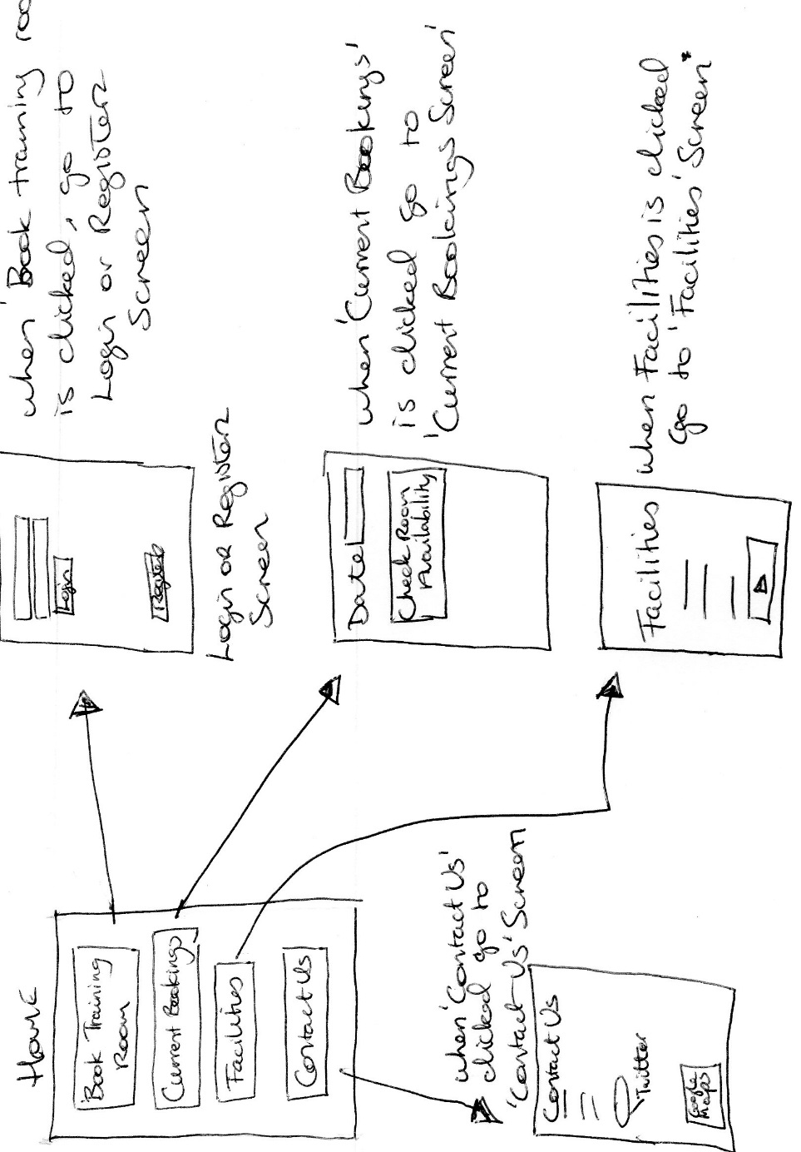

**Book Training Room**

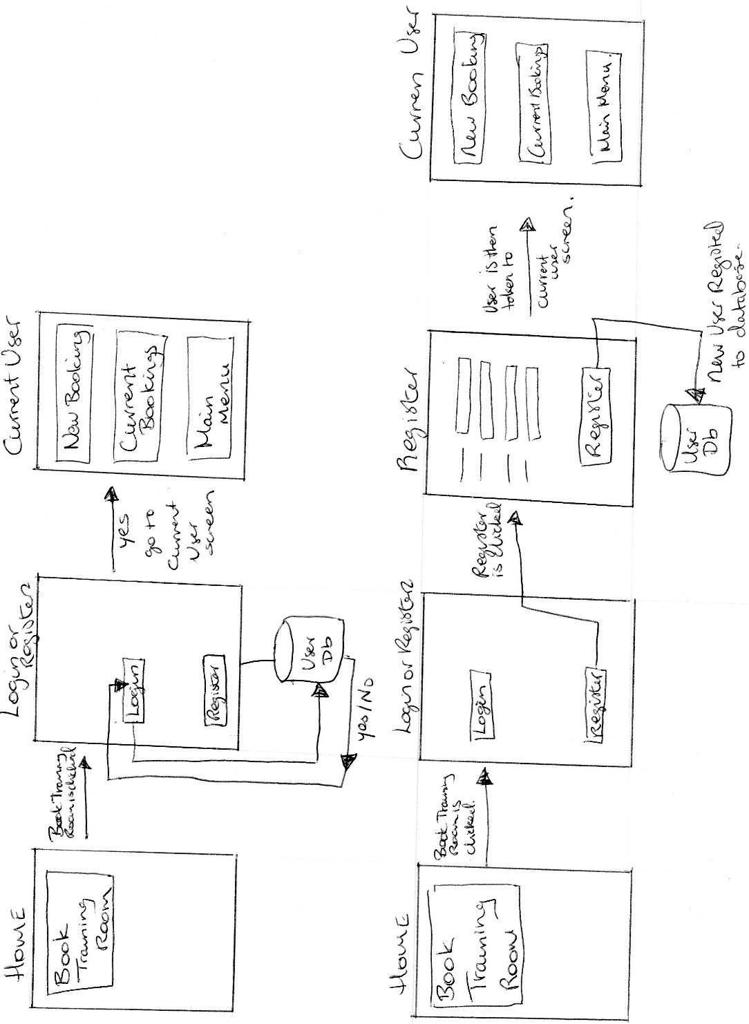

**Book Training Room**

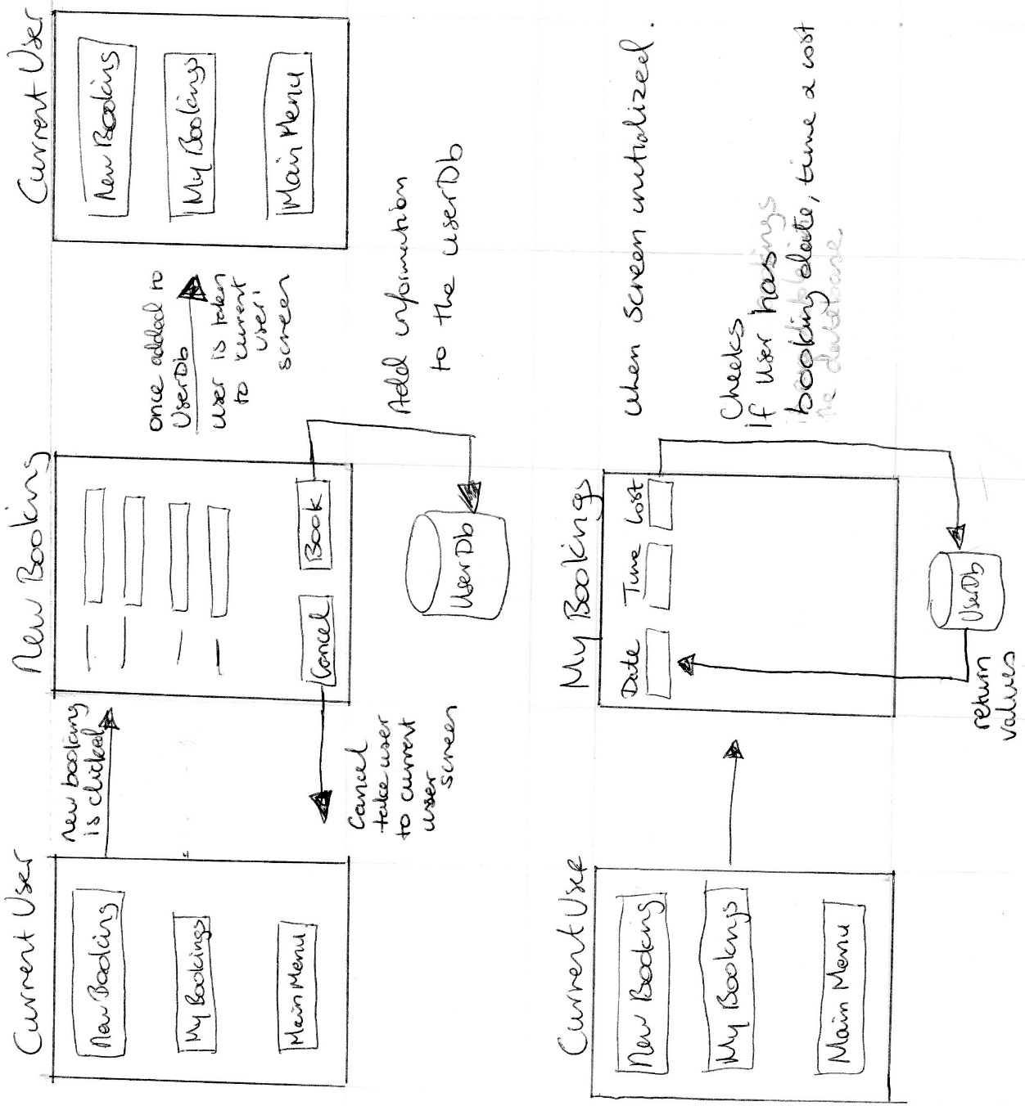

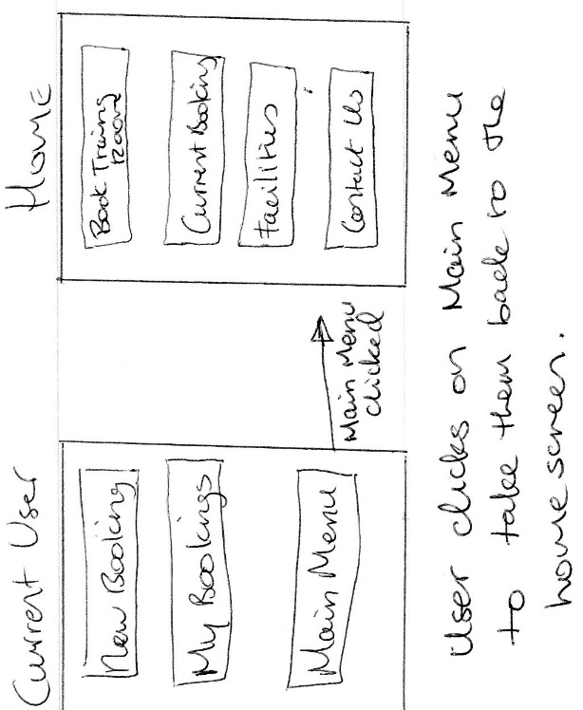

**Current Bookings**

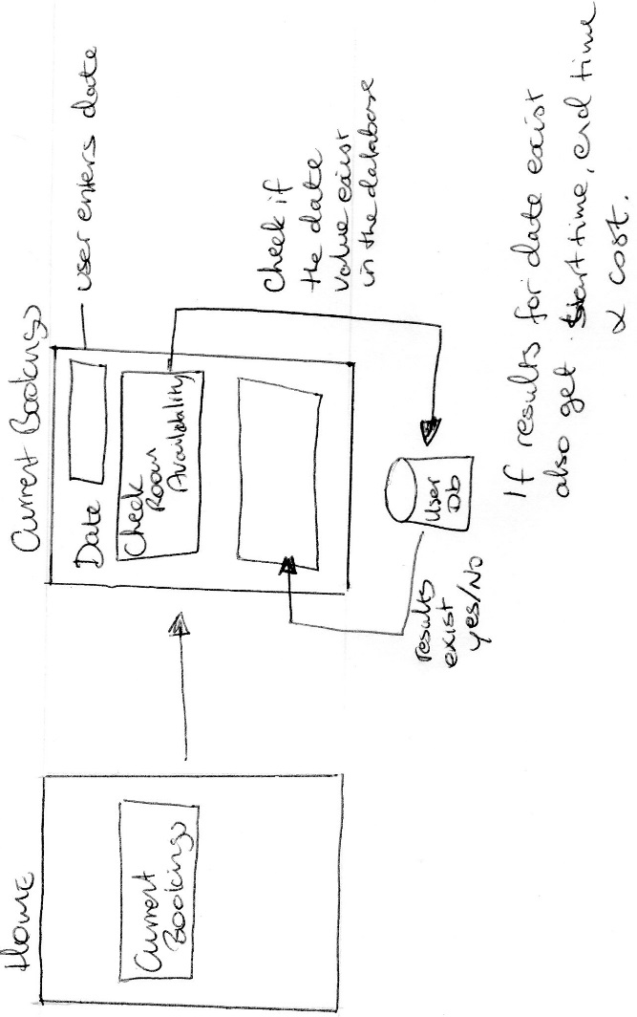

**Facilities**

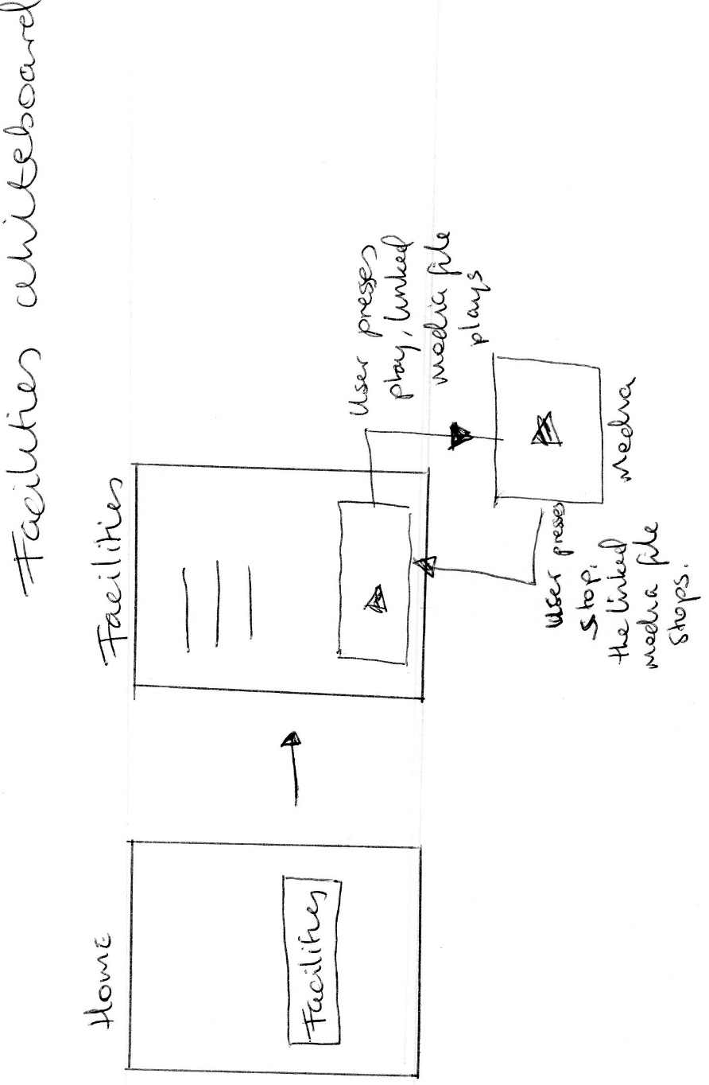

**Contact Us**

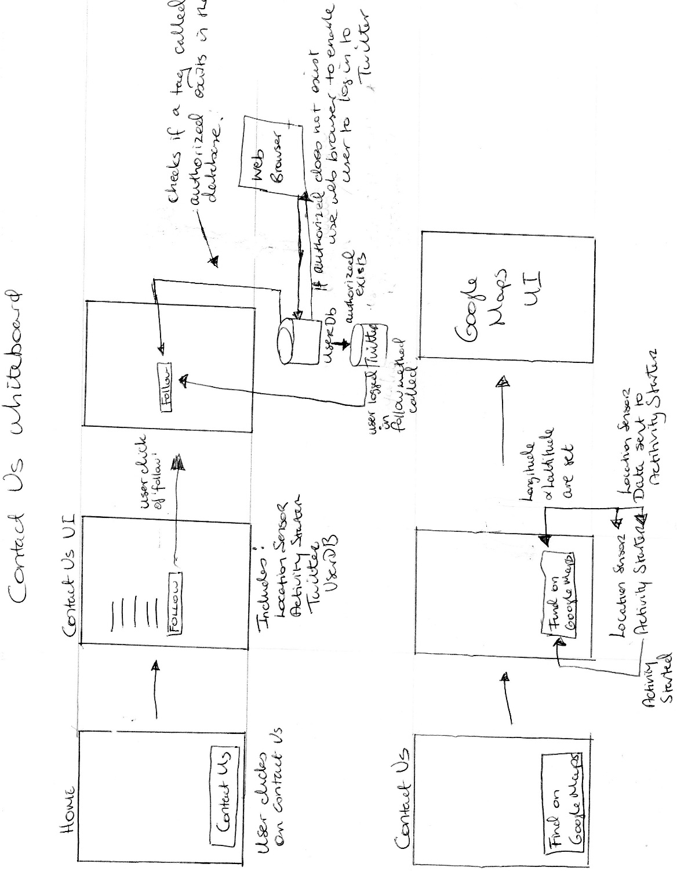

**Access Google Maps from App**

**Access Twitter from App**

## Home Screen

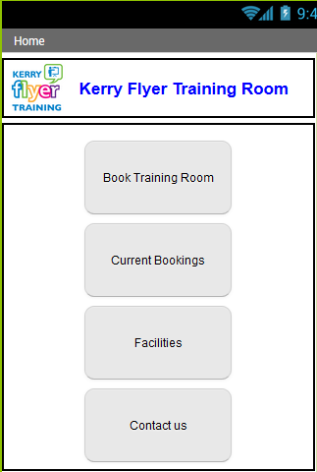

**Home Screen Pseudocode:**

IF ‘Book Training Room’ is clicked:

OPEN ‘Login or Register’ screen

IF ‘Current Bookings’ is clicked:

OPEN ‘Current Bookings’ screen

IF ‘Facilities’ is clicked:

OPEN ‘Facilities’ screen

IF ‘Contact Us’ is clicked:

OPEN ‘Contact Us’ screen

## Log in or Register

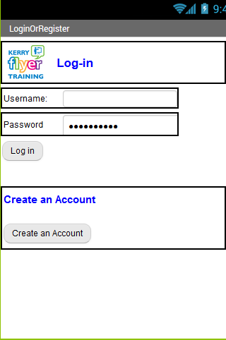

**Login or Register Pseudocode**

IF Log in button is clicked

SET Username& Password key to values from text fields.

CALL user database.

IF username does not exist

SET error message ‘Username is incorrect or does not exist’.

ELSE IF username exist & password is incorrect

SET error message ‘Password is incorrect’.

ELSE IF username field & password field are blank

SET error message to ‘Please fill in the username & password fields’.

ELSE

OPEN ‘Current User’ screen

SET the start value to username.

IF Create an Account button is clicked

OPEN Register screen.

## Register Screen

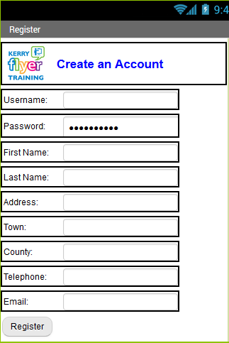

**Register Pseudocode**

IF Register is clicked:

CALL PROCEDURE to check if all text fields are NULL

IF a text field is NULL

SET error message to notify user which text field is NULL

ELSE

SET error message to NULL

CALL PROCEDURE to check if username exists in database

IF Username text field value exists in the database

SET error message to ‘Username already exists’

ELSE

SET error message to NULL

IF error message is NULL

` CALL PROCEDURE to set user keys

SET user keys to a STRING of username_ text field value

CAL PROCEDURE to register users to database

STORE user key and text field values

OPEN SCREEN Book Training Room

SET start value to the username

## Current user

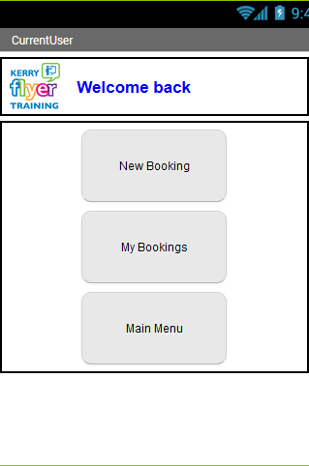

**Current User Pseudocode**

SET the username variable to the start value

ON SCREEN INITIALIZE:

SET ‘Welcome Back’ label to have username appended to label

IF user clicks on ‘New Booking’

OPEN ‘New Booking’ Screen.

SET start value to username.

IF user clicks on ‘My Bookings’

OPEN ‘My Bookings’ Screen.

SET start value to username.

IF user clicks on ‘Main Menu’

OPEN Home Screen

## New Booking

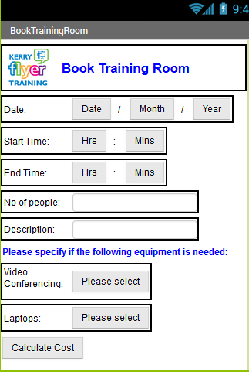

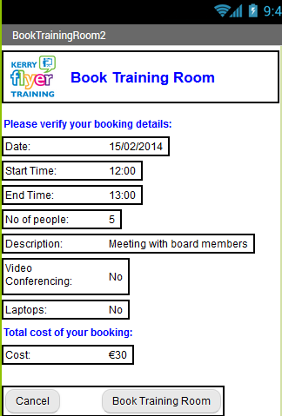

**New Booking Pseudocode**

ON SCREEN INITIALIZE

SET username to start value

GET current time, current month and current year using Clock function.

LOAD the lists:

allBookingDates, allBookingDateStartTimes, allBookingDateEndTimes, currentUserDateTimesList, currentUserStartTimeList, currentUserEndTimesList, currentUser NoOfPeopleList, currentUserDescriptionList, currentUserVideoConferencingList, currentUserLaptopsList, currentUserCostsList

FROM the user database.

SET the results from each list to a new variable of type list. (Values from the text fields will be added to the corresponding new list)

IF Calculate Costs is clicked

CALL PROCEDURE to validate all user inputs such as date, start time, end time, empty fields etc

IF an input is invalid

SET error message to notify user which text field or List Picker value is invalid

ELSE

SET error message to NULL

IF error message is NULL

CALL Procedure Calculate Costs

GET booking duration hours

GET booking duration minutes

IF booking duration mins < 0

SET booking duration mins to booking duration mins + 60

SET booking duration hours to booking duration hours – 1

SET total cost to booking duration hours x 30 (€30 per hour)

IF booking duration mins = 30

SET total cost to total cost + 15 (€15 per half hour)

IF video conferencing is set to YES

SET total cost to total cost + 50 (€50)

IF laptops is set to YES

SET total cost to total cost + 50 (€50)

SET Cancel button to visible

SET Book Training Room button visible to true

ELSE

SET Book Training Room button to visible to false

IF Book Training Room is clicked

SET the value of each user key to have the username appended to the start of each user key.

ADD each text field value to the appropriate list variable for the current user and store this list in the user database.

ADD the date, start time and end time to the list all dates, all start times and all end times and store in the database.

OPEN screen Current User Booking and set the start value to the username

IF Cancel is clicked

OPEN home screen.

## My Bookings

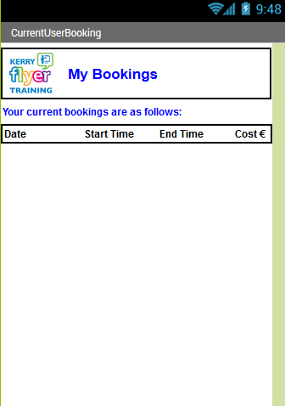

**My Bookings Pseudocode**

ON SCREEN INITIALIZE:

SET the username to the start value

SET all database keys to match the current user’s database keys

CALL procedure display current user booking dates

SET loadCurrentUserBookingDatesListFromDb to the list associated with the current user’s booking dates from the database.

FOR LOOP through the list

SET a label to display each item in the list on a newline

CALL procedure display current user booking start times

CALL procedure display current user booking end times

IF user clicks on Booking Menu

OPEN ‘Current User’ screen.

## Current Bookings

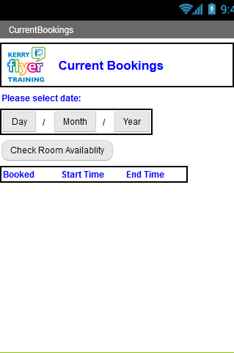

**Current Bookings Pseudocode**

IF Check Room Availability is clicked:

SET the user date to a String of the selected values from the list picker

IF user date is not valid

Display error message

ELSE

CALL check if room booked

SET allBookingDates to the list of all booking dates in the database

SET allStartTimes to the list of all start times in the database

SET allEndTimes to the list of all end times in the database

FOR LOOP through allBookingDates

IF the list item at the current index = selected userdate

SET dates label to display result of list item from allBookingDates at current index

SET start times label to display results of list item from allStartTimes using the current index of allBookingDates

SET end times label to display results of list item from allEndTimes using the current index of allBookingDates

## Facilities Screen



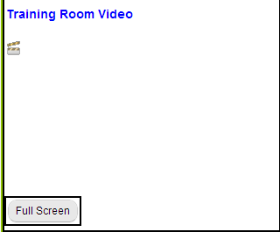

**Facilities Pseudocode**

IF user clicks Play

Video plays

IF user clicks on Pause

Video pauses

IF user clicks on Rewind

Video rewinds

IF user clicks Forward

Video fast-forwards

IF user clicks on Full Screen

Video expands to full screen

## Contact Us





**Find Us Pseudocode:**

ON SCREEN INITIALIZE

SET google maps data uri variable to Google maps URL

IF Google Maps button is pressed

SET Activity Starter Data URI to Google maps URL

START Activity

IF Facebook button is pressed

SET Activity Starter Data URI to Facebook business page URL

START Activity

IF YouTube button is pressed

SET Activity Starter Data URI to Facebook business page URL

START Activity

IF Twitter button is pressed

SET Activity Starter Data URI to Twitter page URL

START Activity

IF Follow button is pressed

SET Twitter Consumer Key & Consumer Secret variables to values associated with Twitter API of this app.

IF a tag exists in the database with the value ‘authorized’

CALL is Authorized method

ELSE

REDIRECT user to web browser to login to Twitter if no authorization.

CALL Follow procedure

SET the user to “KerryFlyerLtd”

# Database Schema

### Database Name

UsersDb – stores all user booking data

TwitterAccessDb – stores the key authorized for Twitter authentication

### Database Keys & Values

The username that the user registers with will be appended to each key to replace the term user.

### User Registration

These are the keys and values that will be used during the registration process.

**Key Value**

user_username username

user_password password

user_firstName first name

user_lastName last name

user_address first line of address

user_town users town

user_county users county

user_telephone phone number

user_email email address

### Booking

These values are associated with the Booking facility of the application.

**Key Value**

user_date date of booking

user_startTime start time of booking

user_endTime end time of booking

user_noOfPeople no of people for the booking

user_description description of booking

user_videoConf yes or no value to see if video conferencing is required

user_laptops yes or no value to see if laptops are required

user_cost cost of booking

### Booking

These values store every single date, start time and end time that is booked

**Key Value**

allBookingDates stores every single booking date in a list

allBookingStartimes stores every single booking date start time in a list

allBookingEndTimes stores every single booking date end time in a list

### TwitterAccessDb

**Key Value**

Authorized stores the value true